SEMESTER TWO
Papers written by
Australian Maths Software

YEAR 12
MATHEMATICS METHODS
Units 3-4
REVISION 1
2016
Section Two
(Calculator–assumed)
Name: _________________________________

Teacher: ________________________________

TIME ALLOWED FOR THIS SECTION

Reading time before commencing work: 10 minutes
Working time for section: 100 minutes

MATERIAL REQUIRED / RECOMMENDED FOR THIS SECTION

To be provided by the candidate
Standard items: pens, pencils, pencil sharpener, highlighter, eraser, ruler.

Special items: drawing instruments, templates, notes on up to two unfolded sheet of A4 paper, and up to three calculators approved for use in the WACE examinations.

IMPORTANT NOTE TO CANDIDATES

No other items may be taken into the examination room. It is your responsibility to ensure that you do not have any unauthorised notes or other items of a non–personal nature in the examination room. If you have any unauthorised material with you, hand it to the supervisor before reading any further.

To be provided by the supervisor

Question/answer booklet for Section Two.
Formula sheet retained from Section One.
Structure of this examination

 | Number of questions available | Number of questions to be answered | Working time (minutes) | Marks available | Percentage of exam
Section One  Calculator—free | 5 | 5 | 50 | 52 | 35
Section Two  Calculator—assumed | 12 | 12 | 100 | 98 | 65
Total marks |  |  |  | 150 | 100

Instructions to candidates

1. The rules for the conduct of this examination are detailed in the Information Handbook.
Sitting this examination implies that you agree to abide by these rules.

2. Write your answers in the Question/Answer booklet.

3. You must be careful to confine your responses to the specific questions asked and to
follow any instructions that are specific to a particular question.

4. Spare pages are provided at the end of this booklet. If you need to use them, indicate
in the original answer space where the answer is continued i.e. give the page number.

5. Show all your working clearly. Your working should be in sufficient detail to allow your answers to be checked readily and for marks to be awarded for reasoning. Incorrect answers given without supporting reasoning cannot be allocated any marks. For any question or part question worth more than two marks, valid working or justification is required to receive full marks. If you repeat an answer to any question, ensure that you cancel the answer you do not wish to have marked.

6. It is recommended that you do not use pencil, except in diagrams.

7. The Formula Sheet is not to be handed in with your Question/Answer booklet.

6. (7 marks)

Consider the diagram below.

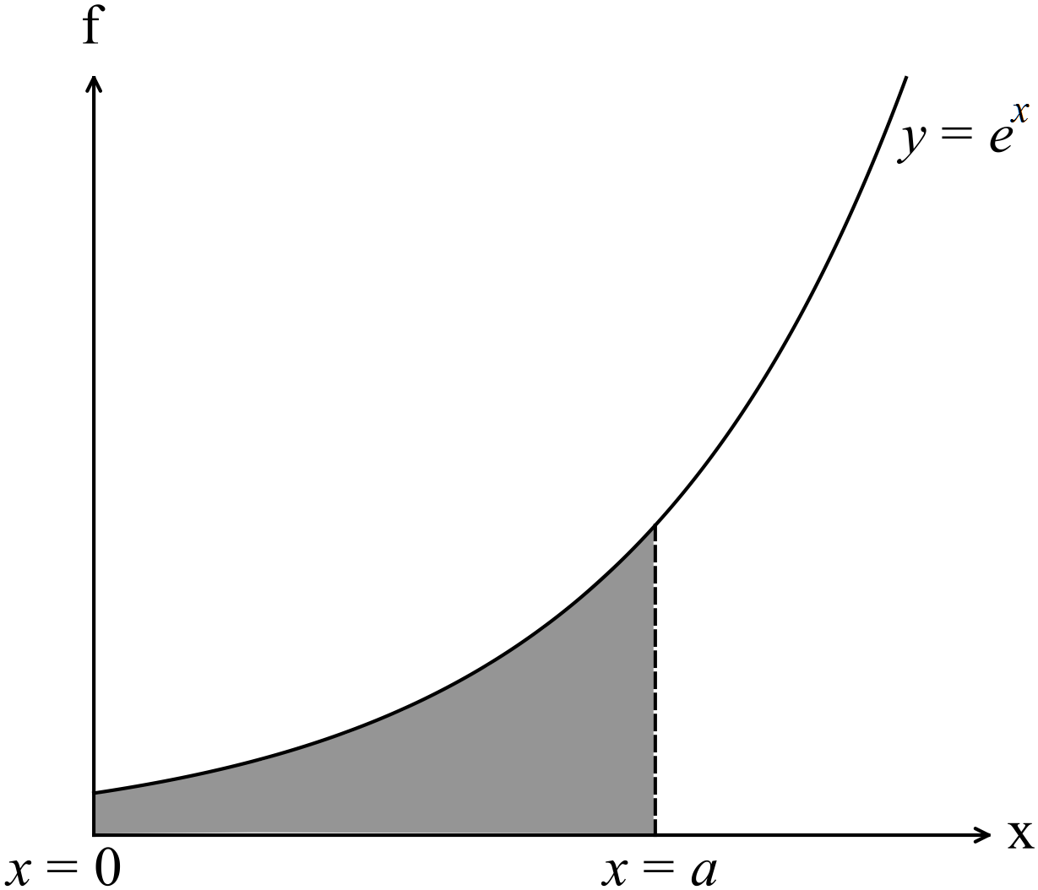

(a) Show that the area under the curve 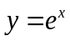 between 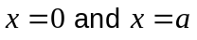 is 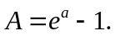 (3)

(b) Use a calculus method to determine the increase in area as increases from 3
to 3.1 units. (4)

7. (6 marks)
A particle with a velocity of 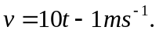
Determine
(a) an expression for the acceleration and the displacement given the initial
displacement is 3 m. (3)

(b) when the particle changes direction. (1)

(c) the distance travelled during the first five seconds. (2)

8. (7 marks)
(a) (i) Find 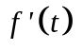given 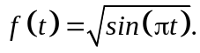 (3)

(ii) Hence find 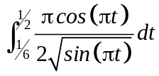 (2)

(b) Let 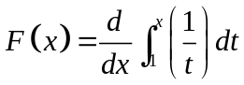
Hence show that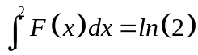 (2)

9. (6 marks)

(Consider the functions 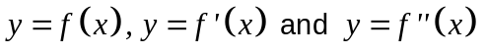graphed below.

. 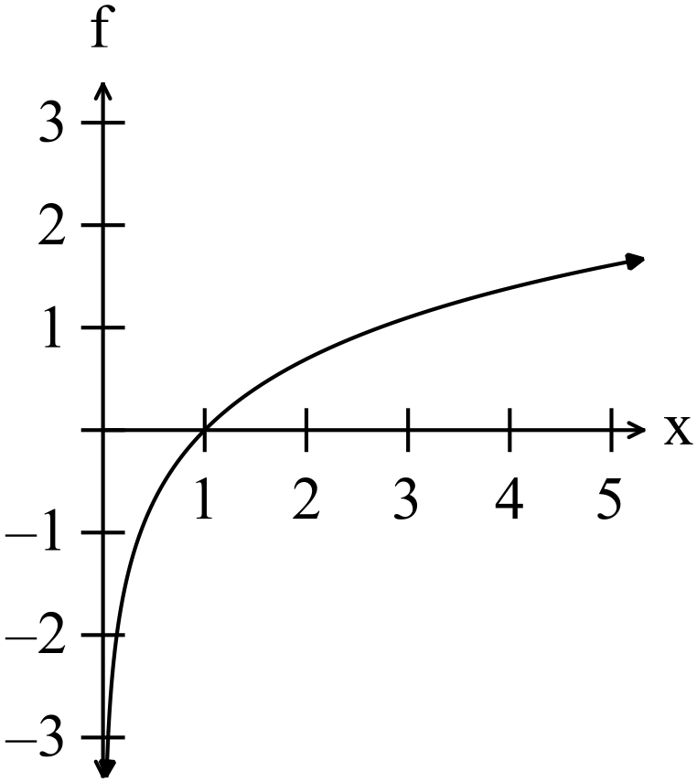

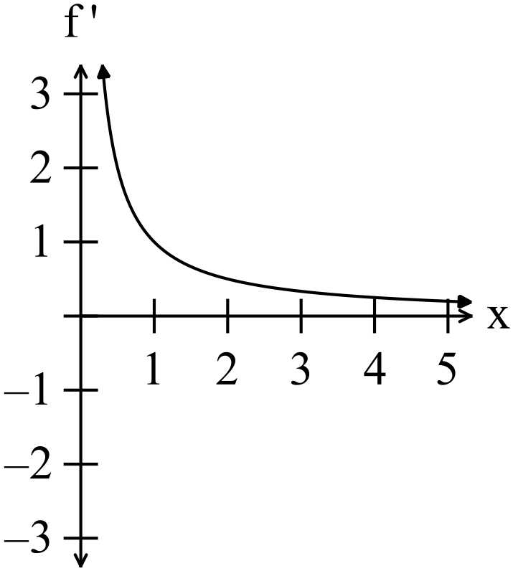

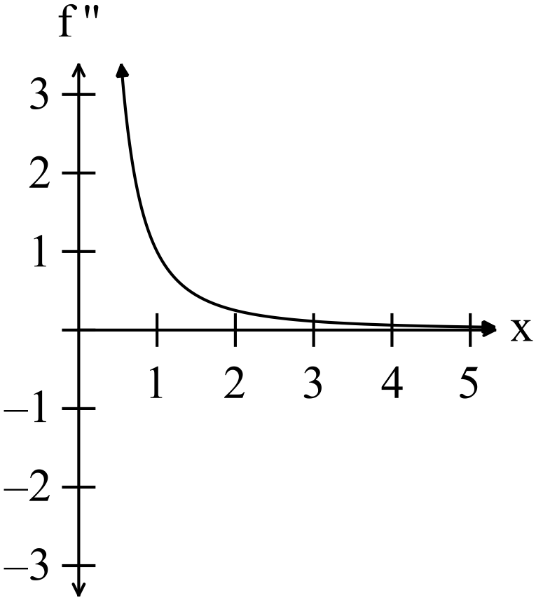

(a) Use the graphs of to explain why
there are no turning points and no points of inflection on the graph of
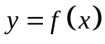. (3)

(b) Comment on the concavity of the graph of with reference to 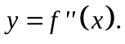 (2)

(c) Determine the equation for each of the three graphs. (3)

10. (7 marks)
(a) Use your calculator to evaluate 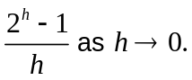 (2)

(b) Determine which of the statements is true and which are false.
Give your reasons.

(i) 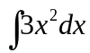 has an infinite number of solutions. (1)

(ii) 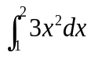 has an infinite number of solutions. (1)

(iii) 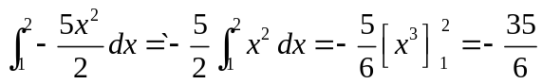. (1)

(iv) If 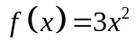
then 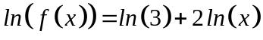. (2)

11. (8 marks)

The population in Egypt in 1950 was close to what the Australian population is today. It
was 23 million people.
In 2010, sixty years later, the population in Egypt was 78.9 million people.
Assume the growth was exponential, so we can use 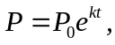where k is a constant
and represents the number of years since 1950.

(a) Determine the value of k and write down the equation that can be used to predict
the population in Egypt. (2)

(b) Predict the expected population in 2016. (1)

The population in Egypt in 2016 was actually 87 238 973.

(c) Is the growth rate of the population stable, escalating or slowing down? (2)

(d) Use the 2010 and 2016 data as a basis to determine the year when the
population of Egypt will equal 100 million. (3)
12. (7 marks)
(a) Use your calculator to find the area enclosed between the two functions
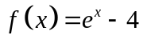 and 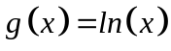 as shown in the diagram below.

The points of intersection are shown.

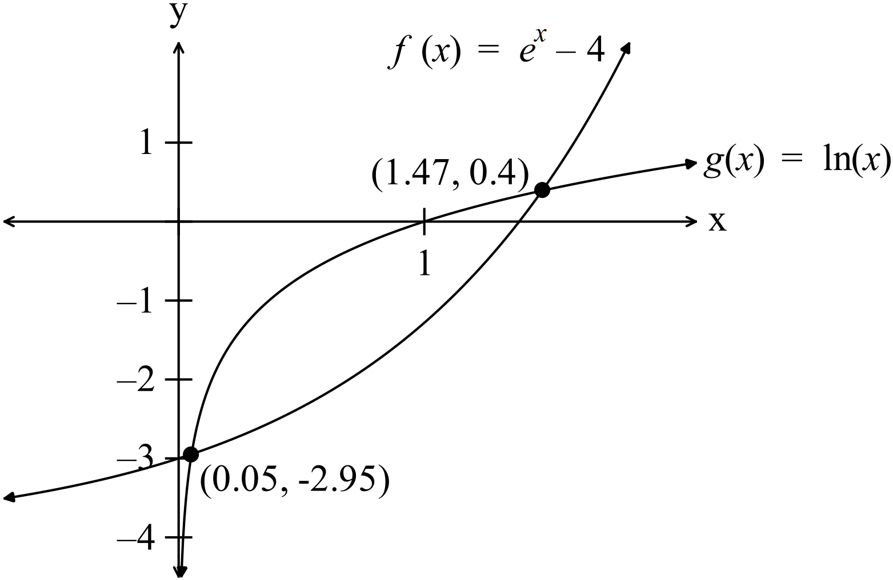 (3)

(b) A small colony of quolls live in hummock grasslands on the sand plains not far
from Port Hedland. The population of this colony was studied in 2002. The
population can be modelled by the equation 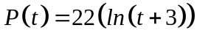 whereis in
years starting in 2002.

(i) What was the population in 2002? (2)

(ii) In what year will the population reach 100? (2)
13. (7 marks)

A rectangle is formed with sides parallel to the axes and a corner on the circle 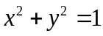. The rectangle is confined to quadrant one.
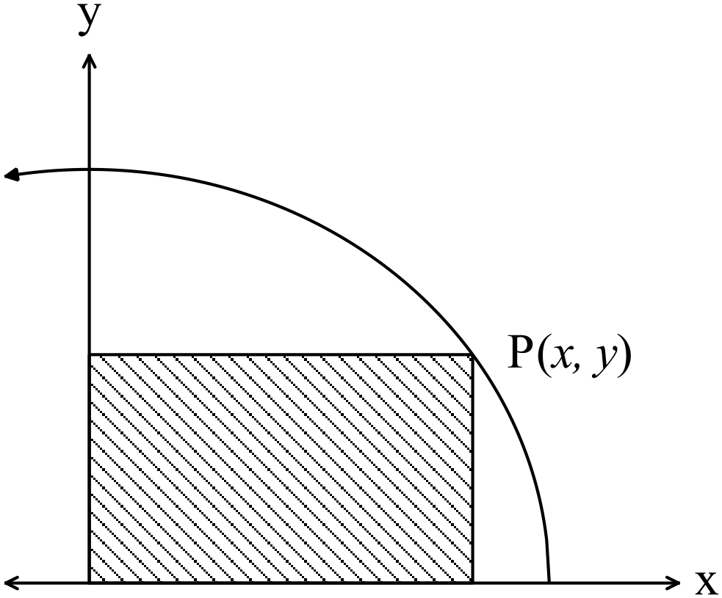

(a) Find an expression for the area of the rectangle in terms of. (2)

(b) Use a calculus method to determine the coordinates of P such that the area of the rectangle is maximised. Show your working. (5)

14. (6 marks)
(a) A survey of 2000 families produced the following data..
Number of children in family | 0 | 1 | 2 | 3 | 4 | 5 | > 6
Number of families | 293 | 732 | 789 | 136 | 30 | 15 | 5

Let 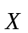 be the number of children per family.

(i) Determine the relative frequencies for the number of children per family in
the chart below. (2)
 | 0 | 1 | 2 | 3 | 4 | 5 | > 6
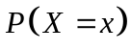

(ii) One of the families is selected at random. What is the probability that the
family has one or two children? (2)

(iii) Determine the mean number of children. (2)

15. (7 marks)
Calculator batteries are claimed to have an average life of 350 hours with a standard deviation of 20 hours.
What is the probability that
(a) a given battery will last at least 400 hours? (2)

(b) a given battery will last between 320 and 380 hours? (2)

(c) Jenny’s battery will run out in a 3 hour exam if it has been used for 340 hours
already? (3)

16. (6 marks)
A maternity hospital had 10 births last Tuesday. Assume that the probability of a boy is
the same as the probability of a birth of a girl.
What is the probability that given ten births
(a) there are 5 girls and 5 boys? (2)

(b) there are no more than 4 boys. (2)

(c) there are exactly 4 girls if the first two births were boys. (2)

17. (22 marks)
(a) Explain briefly what you understand by
(i) a biased sample. (2)

(ii) a randomly selected sample (2)

(iii) a skewed distribution (2)

(b) It is believed that 20% of people who visit vineyards for wine tasting have a
blood alcohol level too high to drive safely after the visit.
Calculate the probability that of the 100 visitors on one particular day that the
number that are affected by alcohol and should not drive is between 18 and 24. (5)

(c) The Year 12 year group was asked if they liked the school ball in term 1.
180 out of 200 liked the ball early in the school year.

(i) Determine the probability that a randomly selected Year 12 student would
like the ball early in the school year.. (1)

(ii) Find the standard deviation of the sampling distribution. (2)

(iii) Estimate the 90% confidence interval for the probability of a randomly
selected Year 12 student wants the ball in term 1. (3)

(d) The proportion of those people favouring the availability of choice of euthanasia
for very ill people in the general population is not known.

What sample size should be used to estimate the probability with an error margin
of 5% at a confidence level of 90%? (5)

